For our case study we have chosen to go with the (Mallawaarachchi, 2017) Model-view-controller pattern this model includes

1. Model, which contains the main functionality (Mallawaarachchi, 2017)
2. View, which is the interface/display that the user can interact with (Mallawaarachchi, 2017)
3. Controller, which enables the user to input into the database (Mallawaarachchi, 2017)

The reason why we are using this is because it is the primarily used architecture for internet based applications and is well supported for Django which we are using. (Mallawaarachchi, 2017)

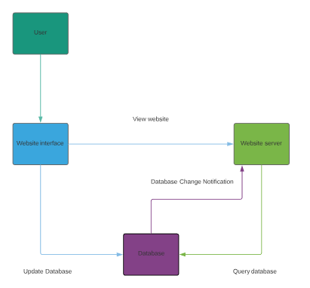 (Mallawaarachchi, 2017)

References

Mallawaarachchi, V. (2017). 10 Common Software Architectural Patterns in a nutshell. Retrieved from <https://towardsdatascience.com/10-common-software-architectural-patterns-in-a-nutshell-a0b47a1e9013>

